SENG2050 – Assessment 3

Development Plan

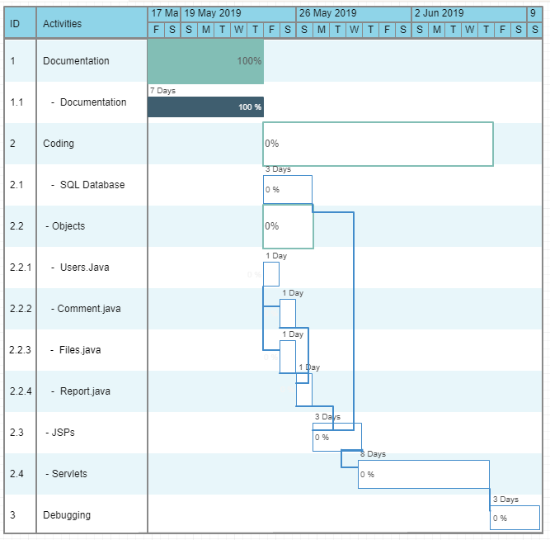

Project Breakdown:

* William:
  + SQL Database
  + Servlets
* Simeon:
  + Java Beans / Objects
  + JSPs
  + Servlets
* Lachlan
  + Servlets
  + Final debugging